1. Given the provided data, what are three conclusions we can draw about Kickstarter campaigns?
   * Some companies could not achieve their goal in the timeframe. 1530 campaigns out of 4114 were failed and it is %38 of the grand total.
   * Theater is the most successful parent category according to the provided data.
   * 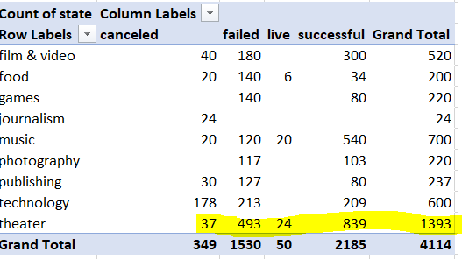
   * June and July hold the most successful month title together. They have even the same count of successful campaign which is 222 per each.
   * 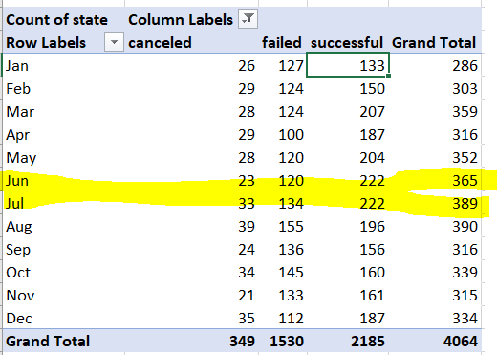
2. What are some limitations of this dataset?

No information about failure.

What is the starting budget per each campaign?

Sub-categories are not deep detailed.

1. What are some other possible tables and/or graphs that we could create?

Percentage of the successful campaigns against the failed ones in the same category and sub-category (It can be change by switching failed against live, live against successful)

What is the grand total collection amount by currency?